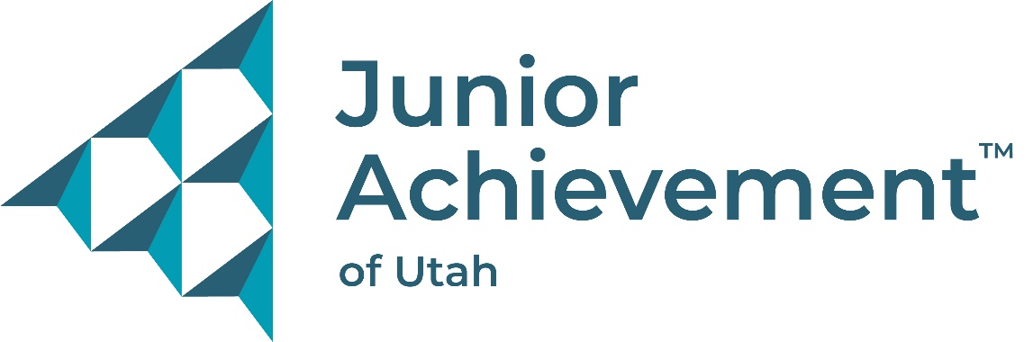

Junior Achievement of Utah

**$2,500 L. Dean Rees Community Volunteer Scholarship Application**

Name:______________________________________________________________________

Address: _______________________________________________________________________

Phone: _____________________________________________________________________

Email: ______________________________________________________________________

School: ________________________________________________________________________________

Junior Achievement Teacher: _______________________________________________________

Grade: ________ Age: ______ GPA: ______

Name of Guardian: _______________________________________________________________________

Name of College or University you plan to attend: _________________________________________ Service Activities in the Community:

Service Activities within School and/or Church Organizations:

Need (with or without this scholarship, how will you support yourself in school):

Knowledge of Junior Achievement (participation in JA K-12 programs, knowledge of JA mission, etc.):

Inside the classroom (report cards, teachers, or administrator's recommendations, etc.):

Outside the classroom (participation in JA programs, science fairs, self-study programs, hobbies, etc.):

Other (any other information you would like us to know about you):

# The L. Dean Rees Community Volunteer Scholarship payment will be credited to and distributed from the student's my529 account. Scholarship recipient will be recognized at the Junior Achievement Governor’s Breakfast to be held in June 2025. Specific date and information to be determined and shared at interview.

# Send completed L. Dean Rees Community Volunteer Scholarship application, letter(s) of recommendation, and transcripts to Junior Achievement of Utah 515 South 700 East, Suite #1F SLC, UT 84102 Attn: Emily Watkins or

# Email to emilyw@ja-utah.org by March 31, 2025. Students selected as finalists will be notified and scheduled for an in-person interview.