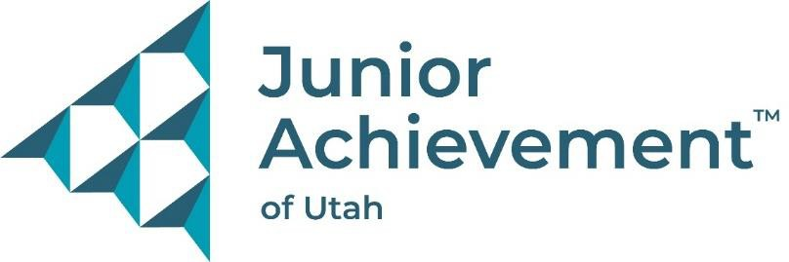

Wayne Cederholm II Memorial U of U Scholarship

The Wayne Cederholm II Memorial (WCII Memorial) started May 2013 after the untimely passing of our father, mentor, and hero. WCII, or “Ceder” as many called him, battled to overcome complications from a bone marrow transplant. He was a major supporter of the University of Utah and had a special passion for empowering youth, which we now continue through this foundation.

Locally, he served as board member and volunteer of Junior Achievement (JA), the nation’s largest organization dedicated to giving young people the knowledge and skills they need to own their economic success, plan for their futures, and make smart academic and economic choices.

The WC II Memorial offers an annual $3,000 scholarship to a deserving high school senior who has displayed exemplary performance in service, achievement, and leadership, and participated in JA programs during their K-12 school career. Students applying must plan to attend the University of Utah during the 25/26 school year.

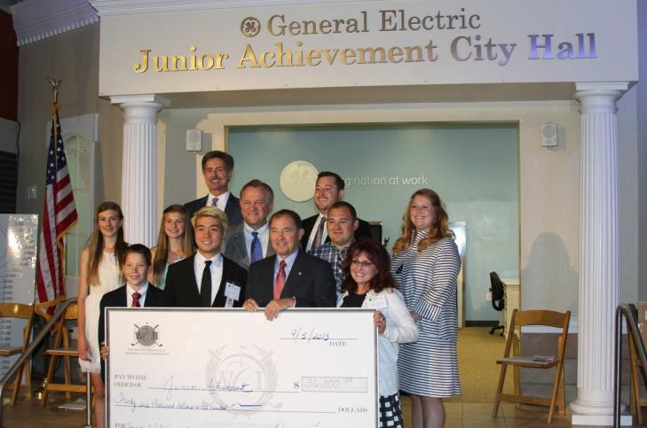Studies show that a student is far more likely to graduate college/university when they have the support, resources, and tools that ensure they graduate their freshman year.

Payment for this Scholarship will be credited to and distributed from the student's my529 account. Scholarship recipient will be recognized at the Junior Achievement Governor's Breakfast to be held June 2025. Date & details to be shared during the interview.

More information about the WCII Memorial scholarship can be found at: <http://www.waynecederholm2memorial.org/>.

**Wayne Cederholm II Memorial University of Utah Scholarship**

$3,000 Scholarship Award

Applicant’s Name:

Guardian’s Name:

Address:

Phone: E-mail:

School: Current GPA:

Junior Achievement Teacher:

Grade(s) Attended JA : Age:

# On another sheet complete the questions below.

1. **Knowledge of Junior Achievement:** Define your participation in JA’s K-12 programs, knowledge of JA’s mission, etc.
2. **School, Community, and Family Activities:** Discuss extracurricular activities, community service, and any other activities that are special to you.
3. **Adversity Requirement:** Write about a time you have had to overcome a significant financial, academic, or emotional hardship.

**Significant Dates**

|  |  |  |  |
| --- | --- | --- | --- |
| **Application Due Date** | **Scholarship Interviews** | **Award Announcement** | **Governor’s Breakfast Presentation** |

|  |  |  |  |
| --- | --- | --- | --- |
| March 31, 2025 | April 2025 | May 2025 | June 2025 – exact date TBD |

Mail or email completed Wayne Cederholm II Memorial – University of Utah Scholarship application to the address/email below.

# Junior Achievement of Utah 515 South 700 East, Suite #1F Salt Lake City, Utah 84102 Attn: Emily Watkins

**or by email to** [**emilyw@ja-utah.org**](mailto:emilyw@ja-utah.org)